Database System Engineering and Distributed Backend Development
Course Code: 25CS1302E
07 Bank Data Bases (SQL VIEWS)
Name: S.Poojitha Reddy
Roll no: 2520030110
Query 1:
2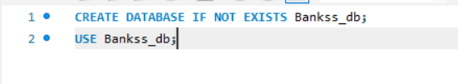
Output:
Query 2:
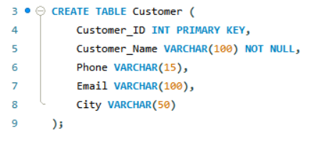
Output:
Query 3:
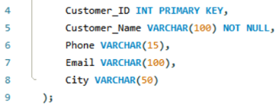
Output:
Query 4:
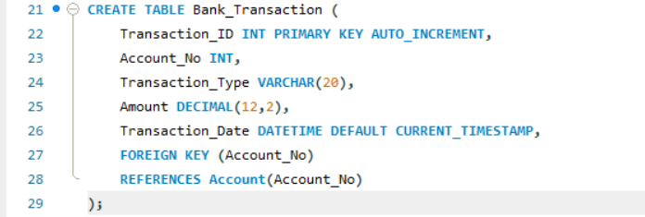
Output:
Query 5:
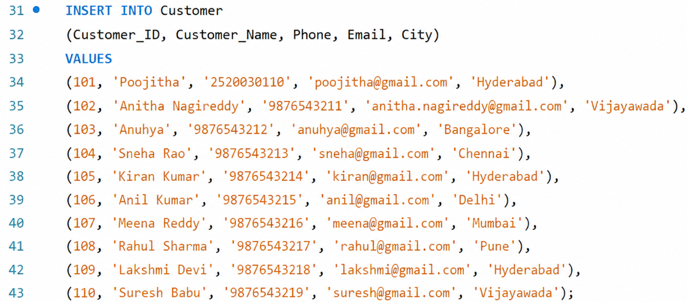
Output:
Query 6:
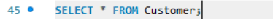
Output:
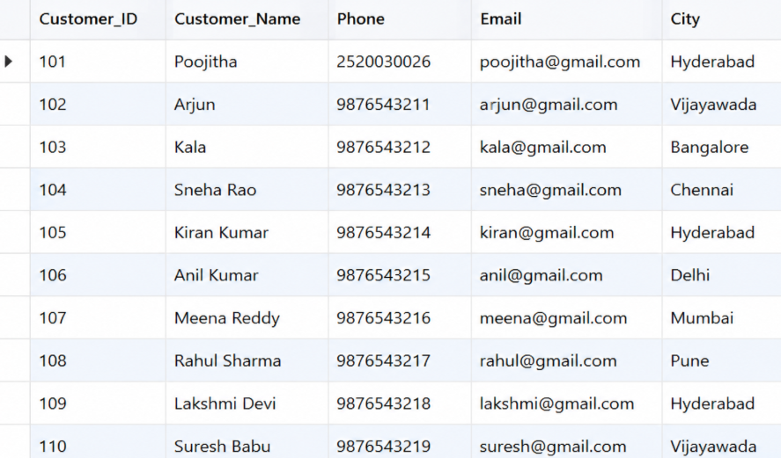
Query 7:
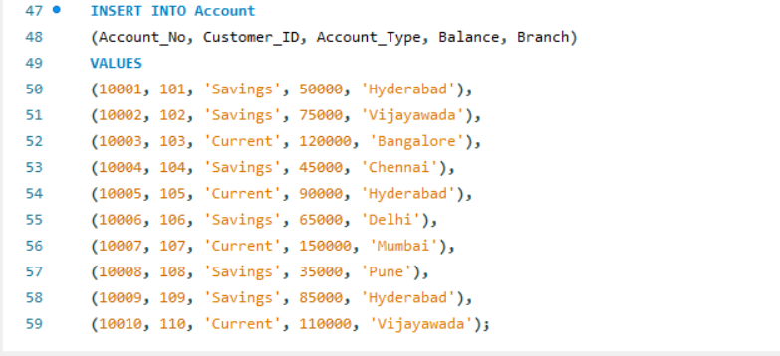
Output:
Query 8:
Output:
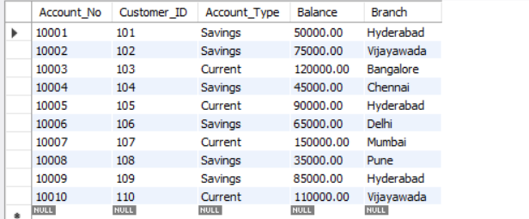
Query 9:
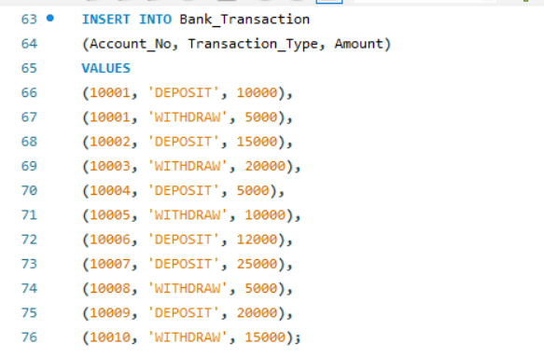
Output:
Query 10:
Output:
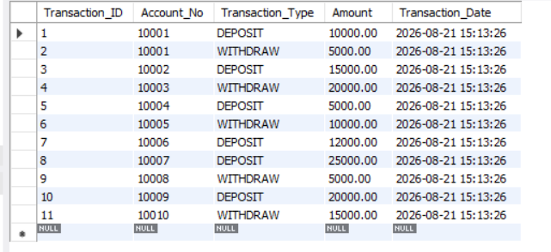
Query 11:
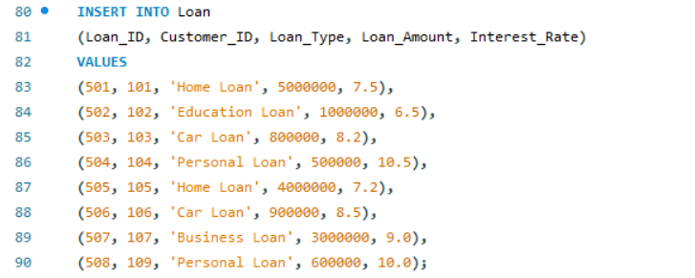
Output:
Query 12:
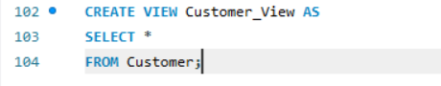
Output:
Query 13:
Output:
Query 14:
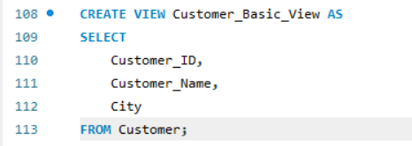
Output:
Query 15:
Output:
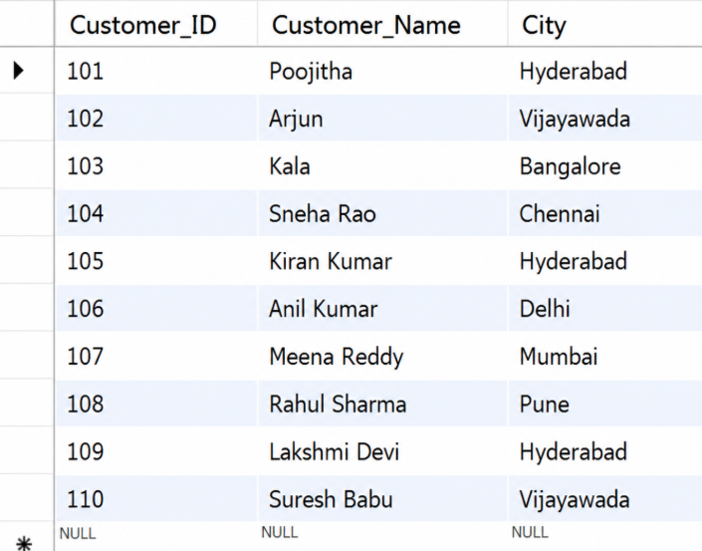

Query 16:
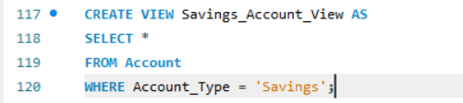
Output:
Query 17:
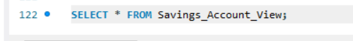
Output:
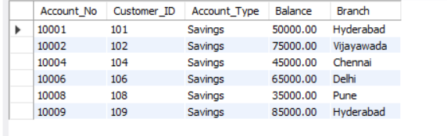
Query 18:
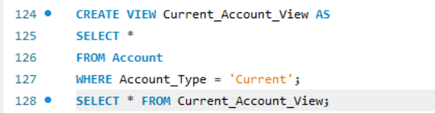
Output:
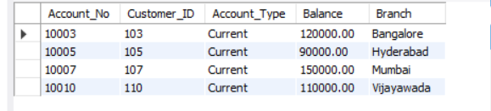
Query 19:
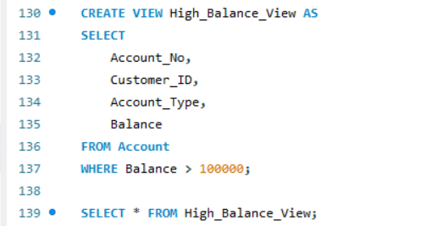
Output:
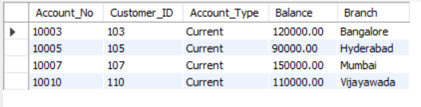
Query 20:
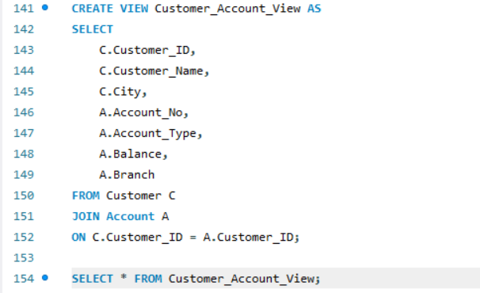
Output:
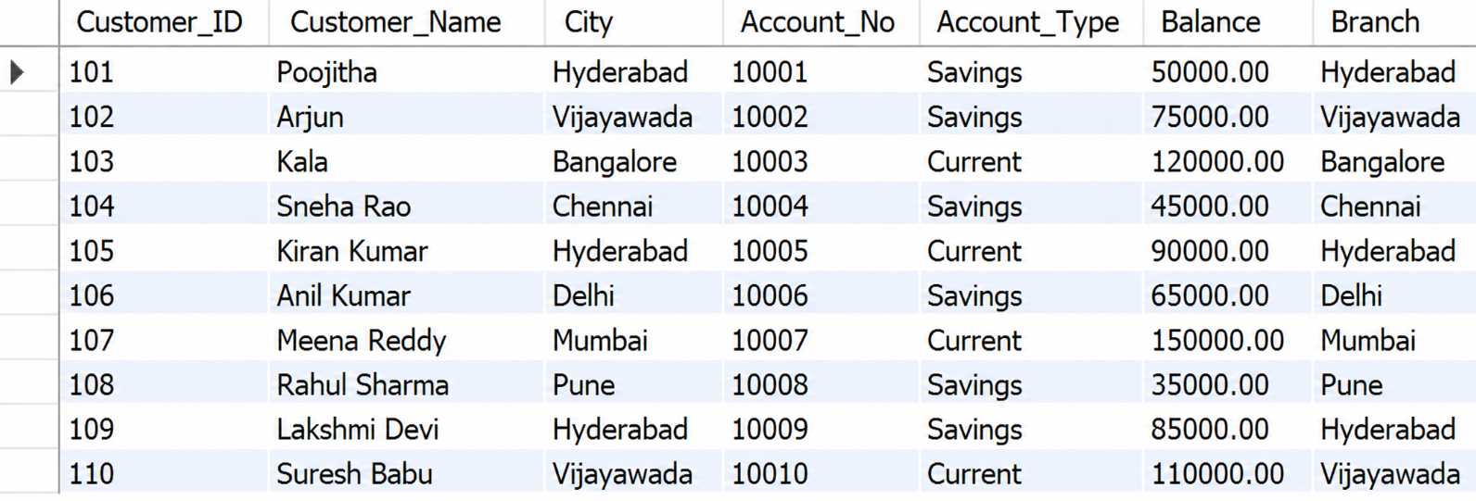
Query 21:
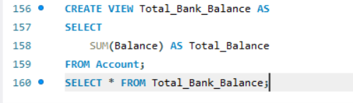
Output:
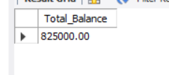
Query 22:
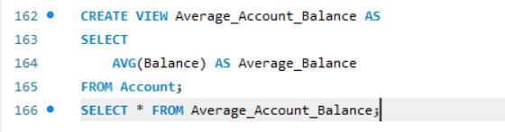
Output:
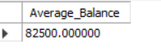
Query 23:
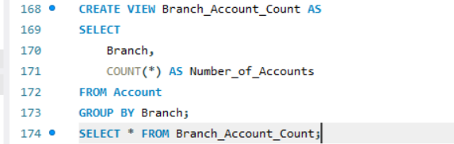
Output:
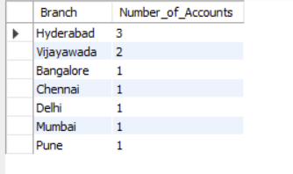
Query24:
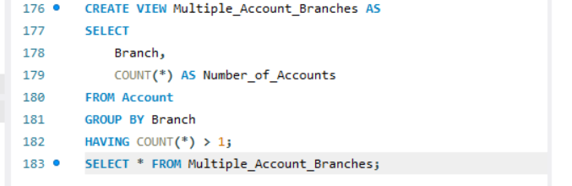
Output:
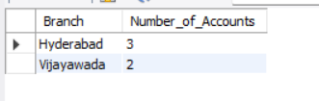
Query 25:
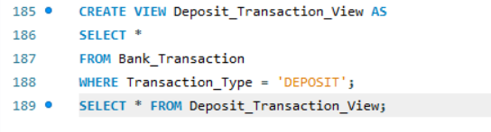
Output:
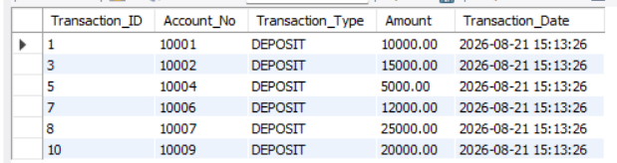
Query 26:
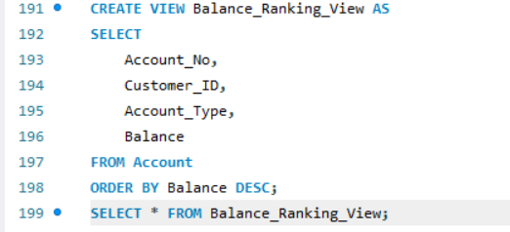
Output:
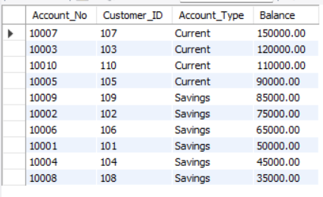
Query 27:
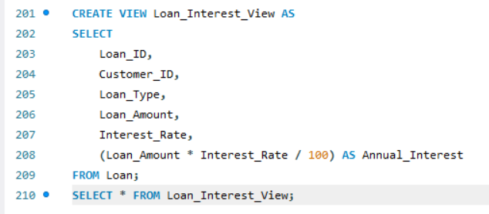
Output:
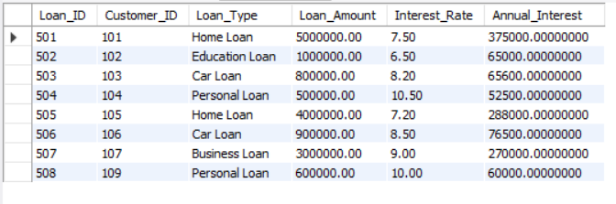
Query 28:
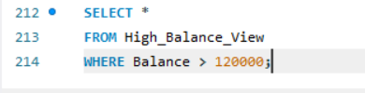
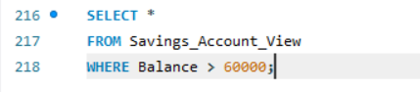

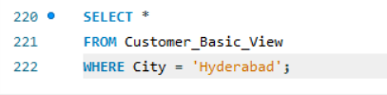

Output:
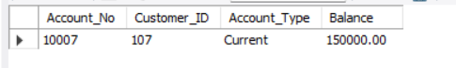
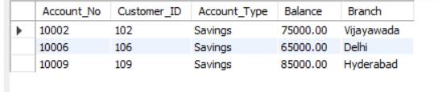
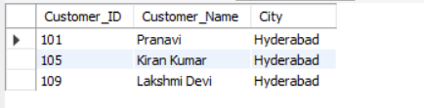
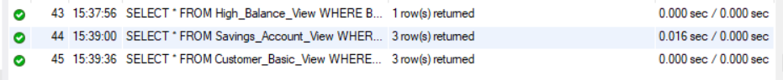
Query 29:
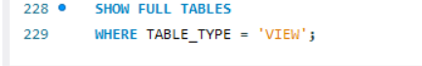
Output:
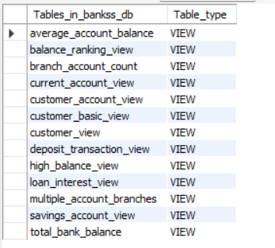
Query 30:
Output:
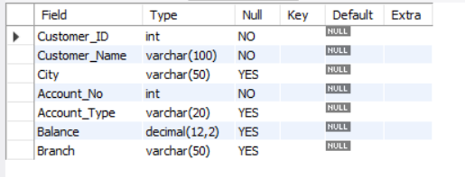
Query 31:
Output:

